Welcome to the Township of Edgetonfieldville City
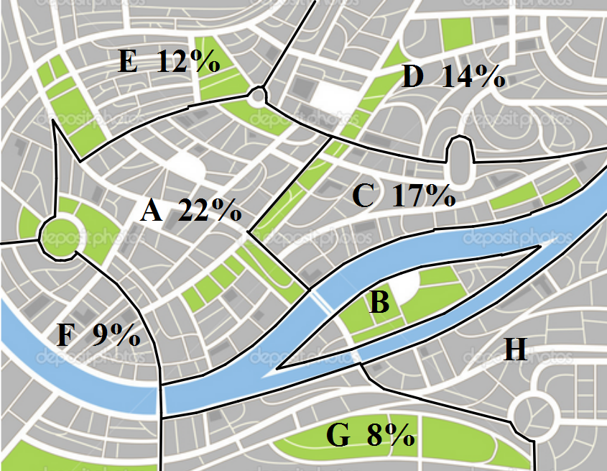
The police in the Township of Edgetonfieldville City have broken the city limits down into 8 Sectors, simply identified with letters A – H. The following map shows how those Sectors are broken up and the percent of the past 200 cases of theft over $300 for the city that occurred in the corresponding Sector.

1) Officer Unla Key spilled coffee on the map and lost the percent for Sectors B and H. The only thing anyone can remember is that Sector B had double the percentage of crime compared to Sector H. What would the missing percentages be? B: H:
2) How many thefts were committed in each Sector?
A: B: C: D:
E: F: G: H:
3) Detective R Rogant grabs one theft case at random to solve on his own…
a. What is the probability that it is in Sector C or F?
b. If he knows the theft happened in a Sector entirely north of the river, what is the probability that it is in Sector D?

4) If Chief Ulysses P Tight decides to pick 4 thefts at random to look into further…
a. If he does not replace, what is the probability that all 4 come from Sector A?

b. If he does not replace, what is the probability that 1 is from Sector E and 3 from Sector G?
c. If he replaces each selection, what is the probability of exactly 2 being from Sector D?
The following lists the top 4 valued thefts in each Sector. These cases are labeled high priority.
A: $12020, $5850, $5200, $4700 B: $3960, $2970, $2840, $2490
C: $5000, $4740, $3950, $3680 D: $4500, $4150, $3860, $3680
E: $5100, $3850, $3720, $2950 F: $4850, $3840, $3680, $2870
G: $3880, $3840, $2490, $1950 H: $3700, $3270, $2450, $2120
5) What is the mean value for high priority cases in each Sector?
A: B: C: D:
E: F: G: H:
6) What is the mean, median and mode value for ALL high priority cases?
Mean: Median: Mode:
7) Which measure of center may be misleading with this data? Why?

8) If the media wants to exaggerate crime in the city which measure of center should they emphasize? Why?

9) If the police want to counter the media to downplay crime in the city which measure of center should they emphasize? Why?

10) What is the range, IQR and SD for ALL high priority cases?
Range: IQR: SD:
11) Make and label a box plot for the high priority cases:

| | | | | | | | | | | | | |
0 2000 4000 6000 8000 10000 12000
12) Do the high priority cases have an outlier? If so, what?
13) According to the box plot how many cases are above $3840?
14) According to the box plot how many cases are between$2960 and $4600?
15) According to actual data how many cases are above $3840?
16) According to actual data how many cases are between $2960 and $4600?
17) If a tip is sent to the police from “Mr. E” that someone is planning to pull off a theft that would make the high priority list what would be the expected value of the theft?
Sector | A | B | C | D | E | F | G | H
Mean Theft Value
% of Theft in Sector

18) If Mr. E later claims that the theft will be in the $5000s, which sector(s) would be the best place to increase police presence? Why?

19) Mayor Sim Pullman allotted extra money to the police force budget. Chief U P Tight decides that it would be best used to create a 9th sector and Mayor Sim Pullman determines to simply split a current sector to create the 9th.
a. Which sector do you think should get split? Why?

b. Sketch on the map where you think it should be split.

c. Which side of your new division would you expect a higher theft rate? Why?

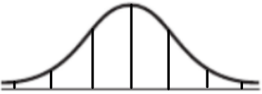
20) If the value of theft fits a normal distribution and the mean of all cases is $2600 with a standard deviation of $1075, then fill in the distribution below:

21) According to the curve, what is the probability that a case chosen at random is valued over $4750?
22) According to the distribution curve what percent of cases are valued below $2600?
23) Based on the curve, how many of the thefts are valued between $1525 and $3675?
24) Based on the curve, how many cases are valued between $450 and $2600?

25) According to the curve how many cases are over $4750?
26) How many cases are actually over $4750?
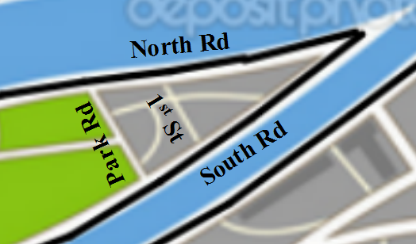
Below is a blown up map of some of the streets in Sector B.
At the very eastern point (far right) of the island is a bank. Mr. E just robbed that bank and is attempting a quick getaway. He takes South Road to get off the island. Detective R Rogant knows that roadblocks are in place along South Road at the park and takes North Road.
27) If it is 7 km from the bank to the edge of the park along South Rd, 9 km from the bank to the corner of the park along North Rd and South Rd and Park Rd make a right angle; then solve the triangle to determine if Detective R Rogant can make the turn from North onto Park safely if he knows he can make a turn of 50º or greater at his current speed?

B angle = PN angle = park road =
28) How far will Detective R Rogant have to travel to get to the North / Park intersection?

29) How far will Mr. E have to travel to get to the North / Park intersection?

30) Mr. E made for his escape 1 minute before Detective R Rogant began his chase. If Rogant is averaging 90 kph and Mr. E is averaging 115 kph aside from losing ½ a minute slowing for the turn, who will make the North / Park intersection first?

31) If Mr. E gets out of his car before making it to the park and is blocked in the area east of the park, what is the area that the police would have to search?

32) If the police begin sweeping the area from Park Rd to the east and have cleared all the way to 1st St. (which also makes a right angle with South Rd. 2 km from Park Rd), what is the remaining area to be searched? (hint: solve the new right triangle)

